


Frequently asked questions about the Nursing Associate Apprenticeship Programme.

Q. What is a Nursing Associate?
A. A Nursing Associate is a registered role that was designed to bridge the gap between the Healthcare Support Worker and a Registered Nurse. This generic role enables Nursing associates to work in a variety of settings and across all four fields of nursing: adult, children’s, mental health, and learning disability in both health and social care. The role was introduced in response to the Shape of Caring Review (HEE,2015) to help build the capacity of the nursing workforce and the delivery of high quality care. Nursing Associate skills and responsibilities vary depending on the care setting they work in. The Nursing and Midwifery Council (NMC) is responsible for registering and regulating Nursing Associates.

Q. What can a Nursing Associate do in practice?

A. The scope of practice for the Nursing Associate is broad and varied depending on your area of work. A Nursing Associate will use professional judgement, work independently under direct and indirect supervision of a Registered Nurse and may expand their scope of practice, within the regulatory framework, through further education and experience after they have qualified and joined the Nursing Associate part of the NMC register. The NMC has developed and published standards of proficiency for nursing associates. This provides information on what nursing associates know and can do when they join the register.
https://www.nmc.org.uk/standards/standards-for-nursing-associates/standards-of-proficiency-for-nursing-associates/

Q. How can I become a Nursing Associate?
A. You will need to complete a 2-year Foundation Degree apprenticeship
programme with an integrated End Point Assessment (EPA).
To complete the required hours to achieve the Foundation Degree, Apprenticeship
Standard and register with the NMC as a Registered Nursing Associate, you will
need to attend University. This is often 1 or 2 days a week depending on the
university. The Nursing Associate apprentice will work towards the NMC Standards
of Proficiency for Nursing Associates (NMC 2018).

Alongside your studies, you will continue to work in your workplace as a
Nursing Associate apprentice (your total hours will not exceed those stated in your
contract of employment).

Q. What qualifications do I need to apply to be a Nursing Associate apprentice and what are the minimum requirements?
A. To apply for the Nursing Associate apprenticeship programme, you will need:

- Be working in a relevant social care or health care role (minimum of 30 hours per week)
- Hold O’ Level / GCSE in English Language and Maths at A*-C or 9-4 pass or Functional Skills in Literacy and Numeracy Level 2.
- Have the right to work in the UK and have a contract of employment for the length of the programme.
- Meet Education and Skills Funding Agency residency rules (living within the UK for the past 3 years)
- An enhanced DBS Certificate, dated within the previous three months prior to the commencement of the programme
- Occupational Health clearance dated at least three months prior to the commencement of the programme
- Some universities require evidence of learning at Level 3 (normally 28 UCAS points, or relevant Access to Higher Education Diploma, or two years of verifiable and relevant work experience).
- Apprentices will need to be able to travel to placement experiences outside their current work-base to meet the programme requirements (any reimbursement of travel costs would need to be discussed and agreed with the employer).

Q. I don’t have Maths and English at GCSE or Functional skills Level 2 in literacy and numeracy Can I still apply?

A. If you don’t hold these qualifications, you will need to be undertake a course to achieve a Level 2 Functional skills in literacy and numeracy before applying for the Nursing Associate apprenticeship programme.
Functional skills level 2 in literacy and numeracy are a recognised alternative to GCSE and are aimed at adults. It focuses more on the skills we need for personal and work life. There are Entry levels 1,2 and 3 and levels 1 and 2 of functional skills. Level 2 functional skills are equivalent to GCSE 9 to 4 (A* to C).
These courses are free and are available through contacting a training provider or your local higher education college/adult learning college. Contact the Nursing Associate project team on: csh.shnursingassociates@nhs.net for further information and guidance.

Q. What is an Apprenticeship and how does the Nursing Associate apprenticeship work?
A. An apprenticeship is a paid job where the employee learns and gains valuable experience. Alongside on-the-job training, apprentices spend at least 6 hours of their working week completing academic based learning with a college, university or training provider which leads to a nationally recognised qualification. Apprentices need to be working a minimum of 30 hours to be meet the apprenticeship criteria (https://www.apprenticeships.gov.uk/) .
The Nursing Associate programme is often funded through the apprenticeship route and is delivered through an NMC approved Higher Education Institute provider (university or college) . The apprenticeship is underpinned by The Standards for Pre-Registration Nursing Associate Programmes (NMC, 2018)

Q. What does the Nursing Associate Apprenticeship Programme involve?
A. The Nursing Associate Foundation Degree Apprenticeship is a full-time programme. You and your employer will need to be committed to the two-year apprenticeship and be able to manage the demands of your job, study and homelife.
The programme requires the apprentice to complete at least 2,300 total programme hours, divided evenly between theoretical and practical learning over the 2 years. You'll undertake academic learning one or two days a week depending on the university and work-based learning the rest of the week. You will be required to undertake exams and complete academic assignments.
You will need to be employed in a healthcare or social care setting such as a care home, community based or a hospice but also gain experience in other settings. A minimum 460 hours over the 2 years will be spent in external practice placements covering adult, mental health, learning disability and children services and working a mix of shifts. This is often completed in 2 placement blocks per year but can vary depending on the university. Some universities will organise or facilitate these placements but not all do. However, the university can guide and advise the employer of some key contacts in the local area of other appropriate employer settings offering potential placements. It is not a requirement of the Nursing Associate apprentice to arrange their own placements. You will also need to complete ‘off the job’ learning which includes your time spent at the university.
During the apprenticeship programme, you are supported by a university academic assessor, a practice assessor and a practice supervisor(s) in your place of work and when you are on your external placements

- A University Academic Assessor - Support the apprentice, the practice supervisor and practice assessor to ensure the planned learning is taking place. Tri-partite reviews are held between the apprentice, the university and the employer / manager to monitor progress.

- Practice Supervisor - The requirement is for a supervisor who can offer support, undertake some assessment including direct observation and who can work with the named Practice Assessor and University Academic Assessor to complete practice assessment documentation and agree achievement of learning outcomes and progression.

- Practice Assessor - All nursing associate apprentices require a Registered Nurse or Registered Nursing Associate who will be their practice assessor. The Practice Assessor conducts assessments to confirm student achievement of proficiencies.

Q. What type of different external placements could I experience?
A. You will need to have experience in working within the four fields of nursing as required by the NMC. These include adult, children, mental health and learning disability services. Examples of these could be community district nursing team, school nurse or health visiting teams, general practice, acute hospital ward such as a surgical ward, community mental health services, special education school, hospice care.

Q. What is the difference between a Registered Nursing Associate and a Registered Nurse?

A. Nursing Associates are members of the nursing team who have gained a Foundation degree and typically involves two years of higher education. Registered Nurses complete three years of higher education and a Bachelor of Science degree (BSc) The Nursing Associate role bridges the gap between a healthcare support worker and a registered nurse. Nursing Associates contribute to the core work of nursing, freeing up Registered Nurses to focus on more complex clinical care. Registered Nursing Associates are usually employed as a band 4 role or equivalent. Both are on different parts of the registers within the Nursing and Midwifery Council.

Chart shows the different platforms of the Registered Nursing Associate and Registered Nurse (NMC,2018)

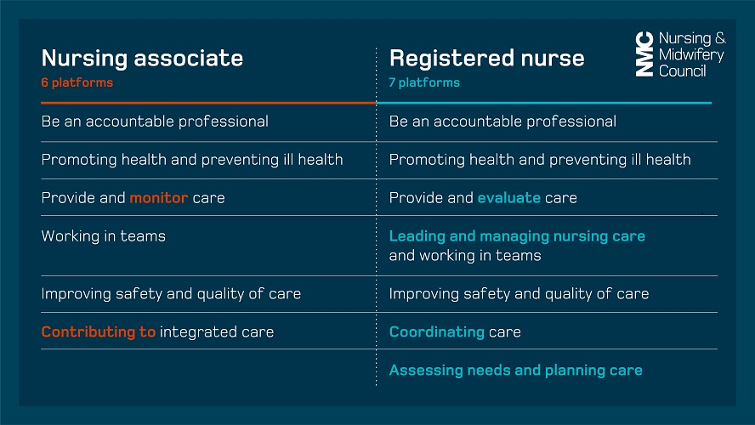

Q. What is the benefit to me and my employer if I apply for this apprenticeship?

A. There are several benefits such as:

- The Nursing Associate apprenticeship offers a clear career progression for unregistered healthcare and social care support workers.
- Improves care through a better educated and skilled workforce. The role is firmly grounded in direct care provision working with patients, families and carers within communities.
- Offers a wider skill mix within the nursing team and releases Registered Nurses to focus on care planning and management, advancing their practice and utilising their high level skills.
- Can help with recruitment and retention levels and job satisfaction
- Can better improve and increase capacity of a service
- Able to deliver care in a range of settings in primary, secondary, community and social care.
- Able to work across a range of population groups and conditions to a defined level of competence with a greater emphasis on community and public health perspectives.
- Greater awareness of boundaries of competence and expertise.
- Able to work within multidisciplinary teams to deliver holistic and person centred care

Q. How can my employer support me during my apprenticeship?

A. Nursing Associate apprentices require support in their place of work and whilst on their external clinical placements. This supervision and learning must comply with the NMC Standards for student supervision and assessment https://www.nmc.org.uk/standards-for-education-and-training/standards-for-student-supervision-and-assessment/
Employers will require a practice supervisor and a practice assessor to support and assess the Nursing Associate apprentice throughout the apprenticeship programme and this is normally Registered Nurses. Training is available for both practice supervisors and practice assessors for Registered Nurses who have not previously been a mentor. Free mentor to practice supervisor/practice assessor mapping sessions are also available through contacting the Surrey Heartland Nursing associate project team.
Clinical practice is documented through the apprentices practice assessment document (PAD), both in the workplace and on clinical placements. The apprentice needs to meet all the programmes requirements and complete year 1 of the programme before they can move onto year 2. This includes both theory and practical aspects of the apprenticeship.
Tripartite reviews occur several times throughout the programme. These are arranged meetings with the university, apprentice and your employer. The meeting is to see how the apprenticeship is progressing and how best you can be further supported.
Q. How can the Surrey Heartlands project team support me?
A. We can support you in a variety of ways:
- Support in the Nursing Associate apprenticeship application process.
- Help you to decide on the most suitable university for you to attend
- Offer ongoing pastoral support
- Offer weekly drop in sessions
- Organise and support with arranging external placements
- Ensure employers are aware of the nursing associate apprenticeship curriculum.
- Offer free mentor to practice supervisor/practice assessor mapping sessions
- Offer free practice supervisor and practice assessor study days for registered nurses to enable them to support you during the apprenticeship

Q: When can I take my annual leave whilst on the apprenticeship?

A: Annual leave should be taken during university holiday weeks and work time. It cannot be taken during placement time and on days that you are scheduled to attend university lectures.

Q. What progression opportunities are available to nursing associates?

A. Nursing Associates can expand their scope of practice through further education and experience after they have qualified. They can also go on to become Registered Nurses by completing a shortened nursing degree or nursing degree apprenticeship.

Q. What funding is available in Surrey to support colleagues enrolling onto the nursing associate apprenticeship?

A. Funding available includes:

- Employers in Surrey can access funding available through Surrey Heartlands and NHS England.

- Surrey Heartlands are currently offering funding for employers. This is £12,045 per apprentice over the 2 years (on a first come first serve basis) and is divided into quarterly payments

- NHS England/HEE offer £8,000 or £15,800 (if working 50% of the time within a learning disability sector) over the 2 years. This is divided into monthly payments.

- Education fees are required by universities and are currently set nationally at a maximum of £15,000 for the full 2-year Nursing Associate programme.
- Nursing Associate apprenticeship, so if you already have apprentices in your organisation, you will not need to set up another account. If the programme is being funding via an apprenticeship, then this education fee is paid through the apprenticeship levy funding. All apprenticeships for small and medium sized employers (payroll of less than £3m per year) can be funded by via a levy transfer from a larger organisation. Once the levy transfer is set up, the funds will move automatically from the organisation gifting to your account to the training provider account, monthly. You will not receive a lump sum payment.
- There is further guidance about apprenticeship funding on the Skills for Care website at: https://www.skillsforcare.org.uk/Developing-your-workforce/Apprenticeships/Apprenticeship-funding.aspx

Q: How do I access the apprenticeship levy funding?

A: You will need to create a digital apprenticeship account (frequently called "DAS") to access funding to pay for apprenticeship training, as well as manage your apprentices training. The DAS can be used for any​ apprenticeship, not just the

You will use the apprenticeship digital account to:
- Get apprenticeship funding.
- Manage training providers.
- Recruit apprentices (if applicable)
- add and manage apprentices.

Before you set up your apprenticeship service account, you will need:
- An email address you have access to
- the Government Gateway login for your organisation OR the accounts office reference number and employer PAYE scheme reference number.
- Authority to add PAYE schemes to the account
- Authority to accept the employer agreement on behalf of your organisation.

Set up your account here:
https://accounts.manage-apprenticeships.service.gov.uk/service/index and there are step by step guidance videos here:
https://www.youtube.com/watch?v=xWUFLAAc4TY&list=PLMNvQX_aIOux3SdHgg3Iw8D8dPrVHbMY7&index=3

You can also get guidance on setting up your account by either calling 08000 150 600 or emailing helpdesk@manage-apprenticeships.service.gov.uk

Q: Who do I contact if I am interested to know more about the nursing associate apprenticeship and how do I apply?
A: Please contact the Surrey Heartlands nursing associate project team on: csh.shnursingassociates@nhs.net.
You will need to complete an expression of interest form which needs to be signed by your organisation and line manager.
Come along to our weekly drop-in sessions if you need more information or have any questions.

